**Assignment Four: Rock Paper Scissors!**

For this activity, you will create the *Rock, Paper, Scissors* game. You will make it both **computer vs. human**game and **computer vs. computer**, depending on what the user selects.

Step 1

First, make a Scratch script that makes the cat and the duck say either Rock, Paper, or Scissors when the green flag is pressed. 

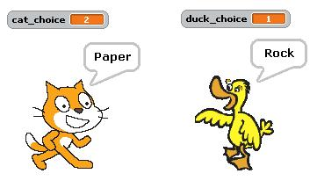

Step 2

Add a third character. After the duck and the cat pick their choice and say it, the third character should say who wins. You may find [this chart](https://canvas.instructure.com/courses/1062553/files/44022595/preview) useful.

Step 3

Add cat score and duck score variables that keep track of how many times each character has won. Make these variables visible on the stage.

*Optional: Use cloud variables to keep track of total wins and losses (over all time, not just this particular run of your program).*

Submit your project as a URL of your published project on the Scratch website.

*Source:* [*Beauty and Joy of Computing*](http://bjc.berkeley.edu/bjc-r/cur/programming/conditionals/rock-paper-scissors.html?topic=pd_bjc%2F02-loops-variables.topic)